|  |
| --- |
|  |
|  |

|  |  |  |  |  |  |
| --- | --- | --- | --- | --- | --- |
| REVISION HISTORY | | | | | |
| Ver. | Description of Change | Author | Date | Approved | |
| Name | Effective Date |
| 1.0 | Initial status | Olga_Hilko | 05-DEC-2017 |  |  |
|  |  |  |  |  |  |

Contents

2. Requested objects 3

3. Materialized Views- Basic 4

3.1. Create Materialized Views - ON DEMAND 4

3.2. Create Materialized Views - ON COMMIT 5

4. Fact Table Loading 5

# Requested objects

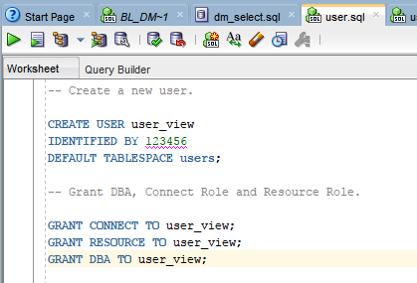

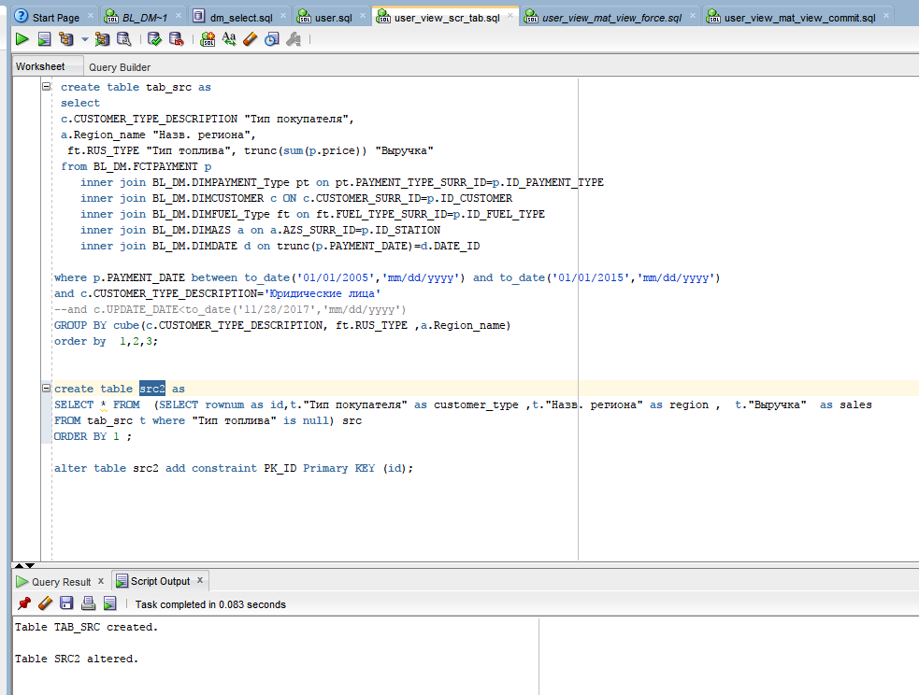

# Materialized Views- Basic

## Create Materialized Views - ON DEMAND

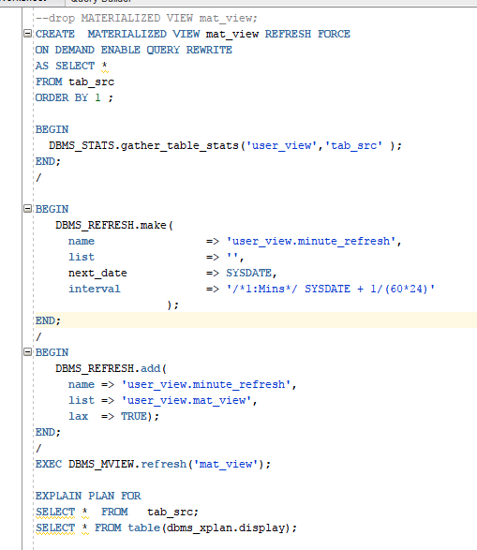

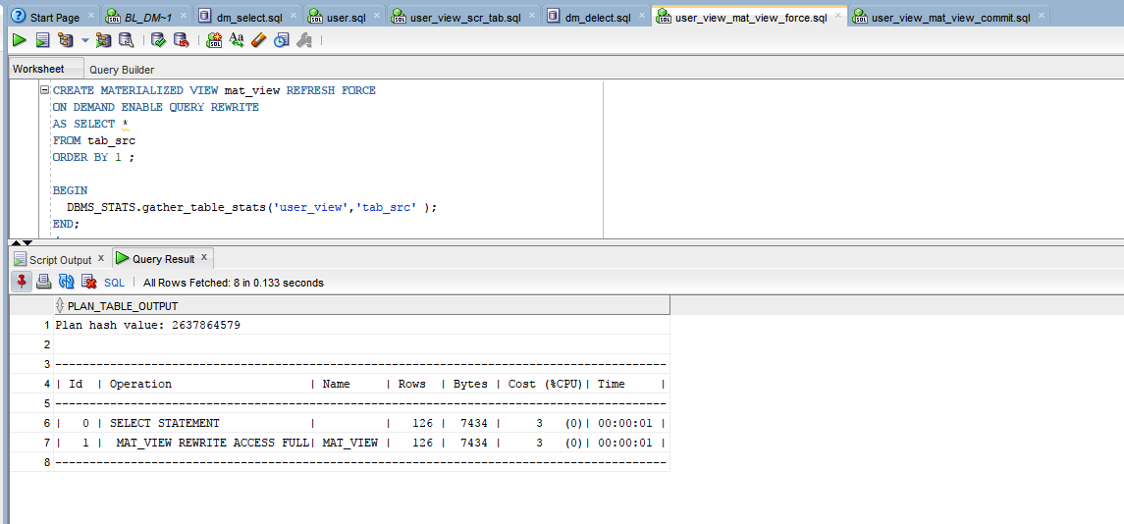

## Create Materialized Views - ON COMMIT

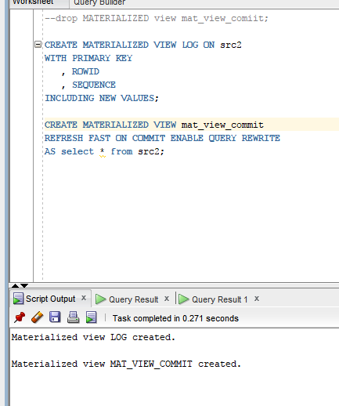

# Fact Table Loading

